Narcissus Nature Morte Mukbang

A Performance by Emily Perry

Narcissus Nature Morte Mukbang by Emily Perry is made in response to Gayle Chong Kwan's photographic series Cockaigne (2004) and the wider art collection at Murray Edwards College – Europe’s largest collection of art by women. It uses humour to explore consumption, feminism, the fetishisation of nature and food in the context of the pandemic and climate crisis.

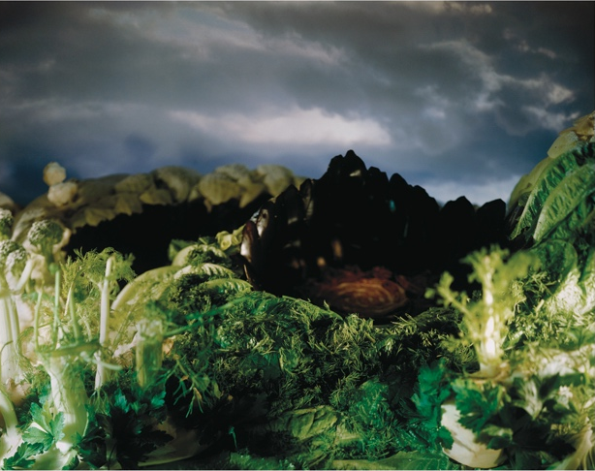
Gayle Chong Kwan
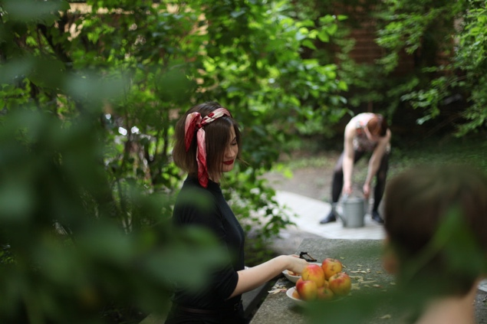
Adonia from the series Cockaigne, 2004

In a time of disconnection, you will practice being yourselves, individually and together, in a guided meditation. You will be invited into the Murray Edwards gardens to ground yourselves in the earth, look deeply, plant vegetables, pick daffodils and breathe.

This meditation subverts established art historical portrayals of women in nature and explores our current eager consumption of nature in the context of climate change and pandemic lockdowns.
A performance by women at the table will sarcastically depict women in relation to food inspired both by art history and contemporary culture. The female performers hopelessly attempt to conduct you as you eat lunch and socialise. You will eat from transparent plates as videos of food-related art and YouTube Mukbang clips play underneath.

The performers pose as table decorations: they bring food to their mouths but don’t eat it; they repeat. They become still life vessels for daffodils and chant clichés. You can observe, respond to or ignore the performing women, like the artworks on the tables and the walls while eating lunch.

The performance will be followed by an artist talk with Gayle Chong Kwan and Emily Perry in the iconic Fountain Court at Murray Edwards.
Emily Perry, Woman with Salad, 2018

Performed by Clio Lloyd-Jacob,
Damaris Athene and Elie Arden
Curated by Naomi Polonsky
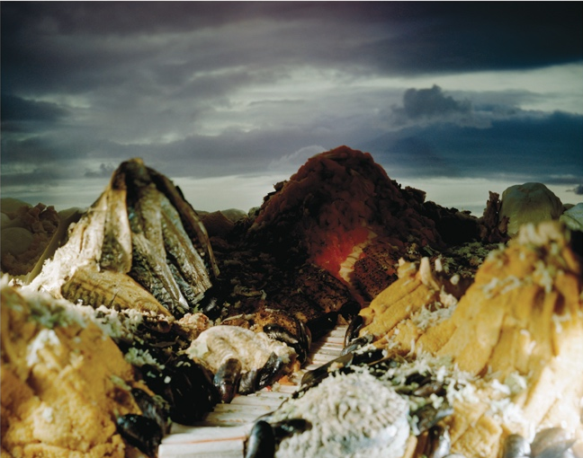
Gayle Chong Kwan
Voyage to the World at the Centre of the Earth
from the series Cockaigne, 2004

About Emily Perry

Emily Perry’s performance practice focuses on gender, sexuality and the representation of women in art history and contemporary culture. Her work reflects on the relationship between appearance and the physical and social constraints that determine identity. Influenced by Marina Abramović, Cindy Sherman and Pipilotti Rist, Perry explores the human, the bodily, the emotional and the grotesque. She creates uncomfortable, socio-artistic situations which force interaction in subtle and frequently humorous ways. Her performances challenge the traditional role of the spectator, as both her works and gallery visitors become the subject, the viewers and the viewed.

About Gayle Chong Kwan

Gayle Chong Kwan is known for her large-scale mise-en-scène environments and photographs, created out of waste products, found materials and documentary sources. Her work highlights the ambiguous relationship between reality, appropriation, and latter-day myths. It focuses on contemporary tourism and trade in relation to their impact upon the landscape. Chong Kwan develops her work through sensory activities, participation and historical or archaeological research. Her settings and props conjure fantastical scenes and experience.
About the New Hall Art Collection
The New Hall Art Collection is Europe’s largest collection of art by women. It includes 550 works by leading artists such as Barbara Hepworth, Paula Rego, Lubaina Humid, Faith Ringgold, Tracey Emin and Cindy Sherman. Founded in the early 1990s, the Collection challenges the underrepresentation of women artists in museums and galleries. In 2018, the Collection was granted Museum Accreditation by Arts Council England.
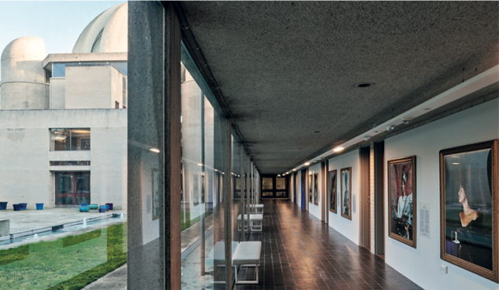
Maud Sulter: The Centre of the Frame, 2021-22 Photograph by Jo Underhill

The Collection is displayed throughout Murray Edwards College, an iconic Brutalist building designed by Chamberlin, Powell and Bon as a manifesto for women’s education. Today,
we continue to celebrate and support women artists, giving them visibility and a voice.
We stage two exhibitions a year, alongside
a vibrant programme of events.

@NewHallArt
To find out more, please head to our https://art.newhall.cam.ac.uk/ or scan the QR code:
